

**YEAR: 9**

**SUBJECT: SCIENCE**

**Semester 2 Exam**

**TIME: 90 mins**

**QUESTIONS: Part A: Multiple Choice Questions (20 marks)**

**Part B: Short Answer Questions (39 marks)**

**Part C: Extended Response (5 marks)**

**TOTAL MARKS: 64 marks**

**DO NOT WRITE ON OR MARK THIS PAPER**

**SECTION ONE: Multiple Choice Questions (1 mark each)**

**Answer this section on the separate multiple – choice answer sheet**

1. Which of the following statements about atoms is true?
2. Neutrons and protons are found in the nucleus with the electrons
3. The number of neutrons found in the nucleus of an atom is always the same
4. Protons circle the nucleus all the time
5. An atom is mostly empty space
6. The nucleus of an atom is made up of
7. electrons and protons
8. protons and neutrons
9. neutrons and electrons
10. neutrons
11. An ion is best defined as: An atom which has
12. lost electrons
13. gained electrons
14. gained or lost electrons
15. gained neutrons
16. The atomic symbol for a gold atom is . Clarify what this tells you about the gold atom.
17. It contains 118 protons.
18. It contains a total of 197 protons, neutrons and electrons.
19. It contains 118 neutrons.
20. It contains 197 electrons.
21. What is the electronic configuration of a chlorine atom? Hint: Chlorine has an atomic number of 17.
22. 2,2,2,2,2,2,2,2,1
23. 2,8,7
24. 8, 8, 1
25. 2,10,5
26. A phosphorus atom has an atomic number of 15. State how many electrons it has in its third (outermost) shell.
27. 0
28. 2
29. 5
30. 8

7. A radionuclide is:

1. a radioactive isotope.
2. a charged atom
3. an element that emits beta radiation.
4. an atom with the same number of protons but a different number of neutrons.
5. The mass number of an atom is the number of
6. neutrons in its nucleus.
7. electrons in the nucleus.
8. protons in the nucleus.
9. protons plus neutrons in the nucleus.
10. Which of the following will cause an atom to become a negative ion?
11. gain electrons.
12. lose protons.
13. gain neutrons.
14. lose neutrons.
15. Scientists use the process of decay in radioactive isotopes called to determine the of organisms.
16. aging; carbon
17. radioactive aging; carbon
18. dating; age
19. carbon dating; age

1. 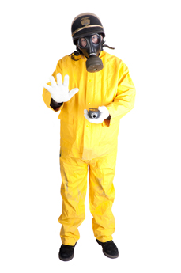Identify which of the following statements best describes a particle with 17 protons, 16 neutrons and 18 electrons.
2. It is an ion because it has lost an electron.
3. It is an atom because it has gained an electron.
4. It is an atom that has lost a proton.
5. It is an ion because it has gained an electron
6. To learn more about electrons, Joseph John Thomson passed an electron beam through a pair of electrodes. He found that the electron beam shifted towards the positive electrode. Given that like charges repel each other and opposite charges attract, deduce what Thomson could conclude about the charge of the electrons.

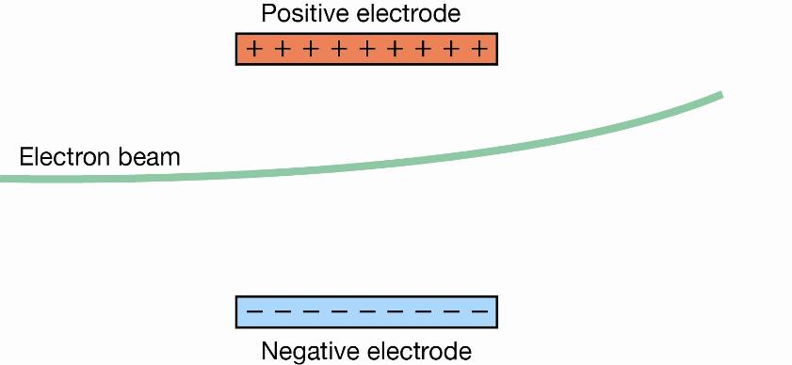

1. Electrons are charged, but might be positively or negatively charged.
2. Electrons are negatively charged.
3. Electrons are positively charged.
4. Nothing can be concluded about the charge of the electrons.
5. Atoms are always electrically neutral because they have the same number of protons and electrons.

* Negative ions (anions) form when an atom gains electrons. They have a negative charge equal to the number of electrons gained.
* Positive ions (cations) form when an atom loses electrons. They have a positive charge equal to the number of electrons lost.

**Use this information to determine which of the following images represents an ion with a charge of -2.**

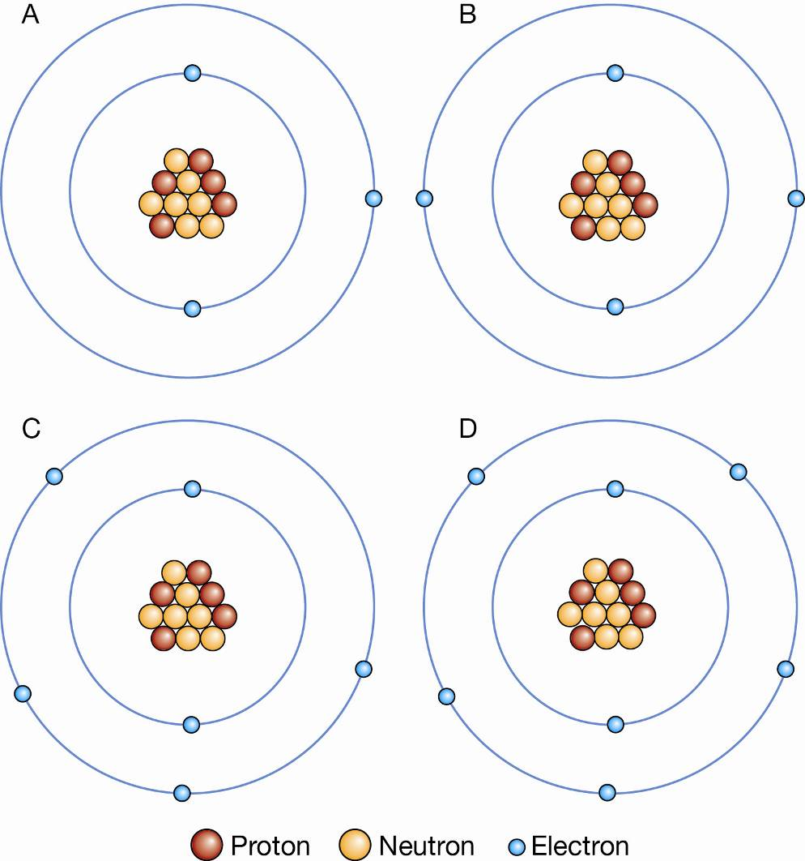

* 1. A
  2. B
  3. C
  4. D

1. State the general name for organisms that cause disease.
2. bacterium
3. antibody
4. pathogen
5. virus
6. Identify the statement about viruses that is **NOT** correct.
7. Viruses are one hundred times smaller than bacteria.
8. Viruses can only grow and reproduce inside the cells of a host organism.
9. Viruses make thousands of copies of themselves inside a host cell.
10. Viruses can only be spread through coughing and sneezing.
11. 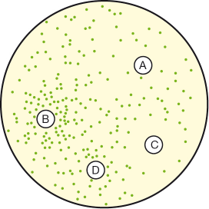Four paper discs were soaked in antibiotics. The discs were placed on a plate with a large number of colonies of bacteria. The aim of the experiment was to test the effectiveness of the antibiotics. After three days the plate was examined. The results are shown above.

Identify the antibiotic that was most effective in killing the bacteria.

1. A
2. B
3. C
4. D
5. Which of these will be in the 1st line of defence?
   1. Skin
   2. Macrophages
   3. Leukocytes
   4. Neutrophils
6. The products of the body’s endocrine glands are
   1. Hormones
   2. Enzymes
   3. Minerals
   4. Ions
7. The central nervous system consists of which of the following from the list below  
   1. Brain, spinal cord
   2. Brain, spinal cord, nerves
   3. Brain, nerves
   4. Brain, spinal cord, pancreas

1. Describe an antibody.
2. a chemical made by the immune system that makes it easier for white blood cells to destroy pathogens
3. a type of white blood cell that consumes pathogens
4. an early antibiotic
5. a chemical that causes your body to react as if you had met a pathogen



**SEMESTER TWO EXAM 2018**

**ANSWER BOOKLET**

**NAME:**

**FORM:** **DATE:**

|  |  |  |  |  |  |  |
| --- | --- | --- | --- | --- | --- | --- |
| **Multiple**  **Choice** |  | **Short Answer** |  | **Extended Answer** |  | **Total** |
|  |  |  |  |  |  |  |
| **20** |  | **39** |  | **5** |  | **64** |

|  |  |  |  |  |
| --- | --- | --- | --- | --- |
| 11 | a | b | c | d |
| 12 | a | b | c | d |
| 13 | a | b | c | d |
| 14 | a | b | c | d |
| 15 | a | b | c | d |
| 16 | a | b | c | d |
| 17 | a | b | c | d |
| 18 | a | b | c | d |
| 19 | a | b | c | d |
| 20 | a | b | c | d |

**SECTION ONE:** Multiple choice answers Cross (X) through the correct answer.

|  |  |  |  |  |
| --- | --- | --- | --- | --- |
| 1 | a | b | c | d |
| 2 | a | b | c | d |
| 3 | a | b | c | d |
| 4 | a | b | c | d |
| 5 | a | b | c | d |
| 6 | a | b | c | d |
| 7 | a | b | c | d |
| 8 | a | b | c | d |
| 9 | a | b | c | d |
| 10 | a | b | c | d |

**SECTION TWO: Short Answer (39 marks)**

Answer the questions in the spaces provided.

**Question 21** Identify the number of protons, neutrons and electrons in the following atoms: (6 marks)

39K1923Na11

1. Protons ___________ a) Protons __________
2. Neutrons__________ b) Neutrons _________
3. Electrons __________ c) Electrons ________

**Question 22** For each of the electron configurations below, construct an electron diagram and write the name of the element you have drawn.

(8 marks)

Electron Configuration: **2, 8, 1** Electron Configuration: **2, 7**

Element: ______________ Element: ________________

Electron Configuration: **2, 8, 6** Electron Configuration: **2, 8** Element: ________________ Element: _______________

**Question 23**

Describe how a stable atom changes if you change the number of: (3 marks)

1. electrons

1. neutrons

1. protons

**Question 24**

Carbon has different isotopes, as shown in the diagram below.

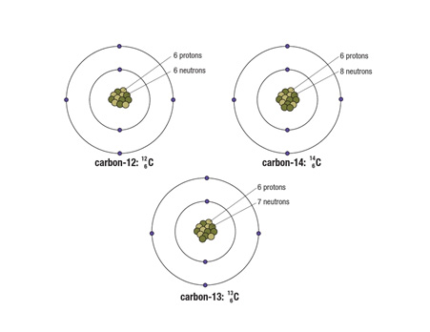

Describe the similarities and differences between these shown. (3 marks)

**Question 25**

The atoms below are written using the letters V to Z instead of their correct chemical symbols.

     (4 marks)

1. Which two atoms have the same number of neutrons?

______________________________________________________________________________

1. Which atom has the smallest mass number?

______________________________________________________________________________

1. Which two atoms belong to the same element?

______________________________________________________________________________

1. Which atom has the electron configuration 2, 8?

_____________________________________________________________________________

**Question 26**Cassie and Stuart were given the task to find the half-life of a new radioactive element that has been produced as a result of reactions occurring in a nuclear reactor. They used a Geiger counter to measure the numbers of decays per minute at different elapsed times as shown in the table.

|  |  |  |  |  |  |  |  |  |  |  |  |  |  |
| --- | --- | --- | --- | --- | --- | --- | --- | --- | --- | --- | --- | --- | --- |
| Time period (mins) | 0 | 5 | 10 | 20 | 25 | 30 | 35 | 40 | 45 | 50 | 55 | 60 | 65 |
| Counts (decays per min) | 2520 | 1978 | 1492 | 1228 | 1015 | 883 | 694 | 621 | 557 | 473 | 406 | 364 | 322 |

(a) Plot an appropriate graph using the above data on the graph paper provided. (5 marks)

(b) Use the graph to calculate the half-life of the sample. (2 marks)

___________________________________________________________________________

**Question 27.** Explain why a person is unlikely to suffer from measles as an adult if they had measles as a child. (2 marks)

___________________________________________________________________________

___________________________________________________________________________

___________________________________________________________________________

___________________________________________________________________________

**Question 28**a) Using the word bank below, match the word to the part of the neuron. (3.5 marks)

Dendrite Myelin sheath Cell body Axon Nucleus Synapse Direction of impulse

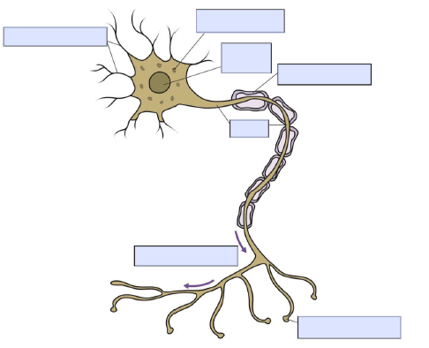

b) What are the 3 types of neurons? (1.5 marks)

__________________________________________________________________________________

__________________________________________________________________________________

c) How is information passed from sensory neuron to the motor neuron? (1 mark)

__________________________________________________________________________________

**SECTION THREE: Extended Response (5 marks)**

Select either question **ONE or TWO** and write the question number in the box below. Answer the question in the space provided. Question 2 has 3 parts.

1. Explain why oxygen atoms ionise to form the oxide ion with a charge of –2. Identify if oxide is an anion or a cation.
2. Some isotopes of the elements are unstable. This means they may undergo decay or change into another isotope and emit certain radiations.
3. List three types of radiation in order from least penetrating to most penetrating.
4. Compare the (similarities and differences) properties of those radiations. You need to show at least two properties for each radiations.
5. What do you mean by the term half-life of a radioactive material?

**Question Number:**

**END OF EXAM**Please go back and check your work /

complete any unanswered questions. REMEMBER blank spaces cannot get marks!